|  |  |
| --- | --- |
|  |  |

**Faculty of Technology and Engineering**

**Chandubhai S. Patel Institute of Technology (CSPIT)**

**Department of Computer Science & Engineering**

Date: / /

**Laboratory Manual**

|  |  |  |  |  |  |
| --- | --- | --- | --- | --- | --- |
| Academic Year | : | 2024-25 | Semester | : | 4 |
| Course code | : | CSE206 | Course name | : | DATABASE MANAGEMENT SYSTEM |

|  |
| --- |
| **Practical - 5** |
| **Aim:** As a database administrator for a global bank, you are responsible for managing and analyzing employee and customer data stored in the bank’s database. Your tasks involve using SQL functions to manipulate and retrieve critical information efficiently. These operations ensure seamless data communication and compliance with bank regulations.  Constraints  • **Not Null Constraints**: Critical fields like names and salaries must not be null.  • **Unique Constraints**: Ensure integrity of fields like Job_ID.  • **Check Constraints**: Validate positive salary values.  The bank maintains the following schemas:  **1. JobProfile Table**: Stores details of employees and their job roles.   * Emp_ID (Primary Key) * Emp_Name (Not Null) * Emp_Salary (Not Null, Check: Greater than zero) * Job_ID (Unique) * Department   2. **Customer Table**: Stores customer details.   * Cust_ID (Primary Key) * Cust_Name (Not Null) |

**Tasks:-**

The HR department wants to analyze employee salaries for better planning. Write SQL queries to:

1. Calculate the average salary of employees (with and without duplicates).

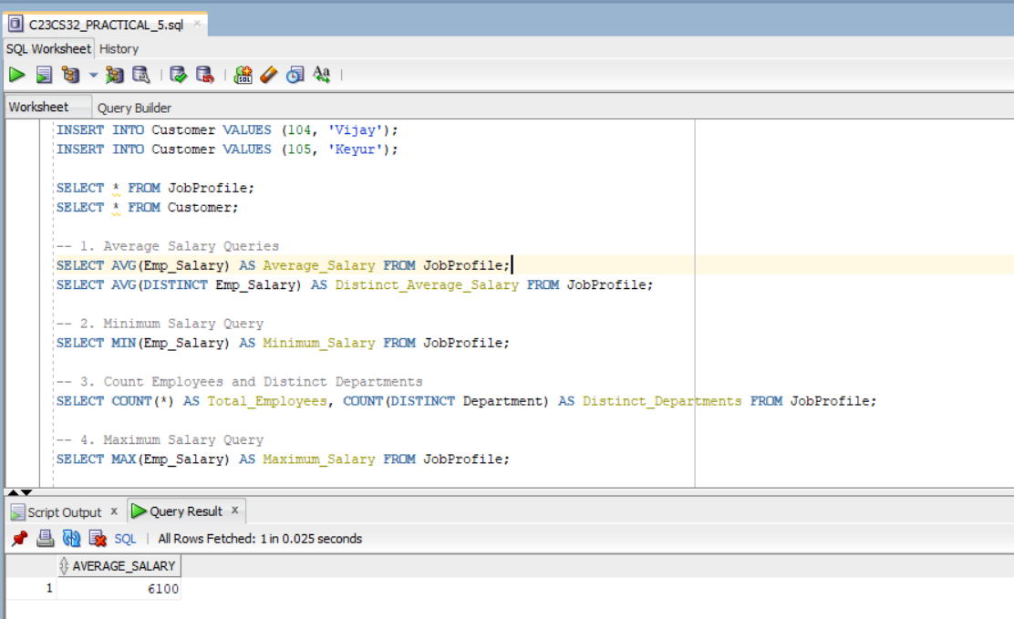

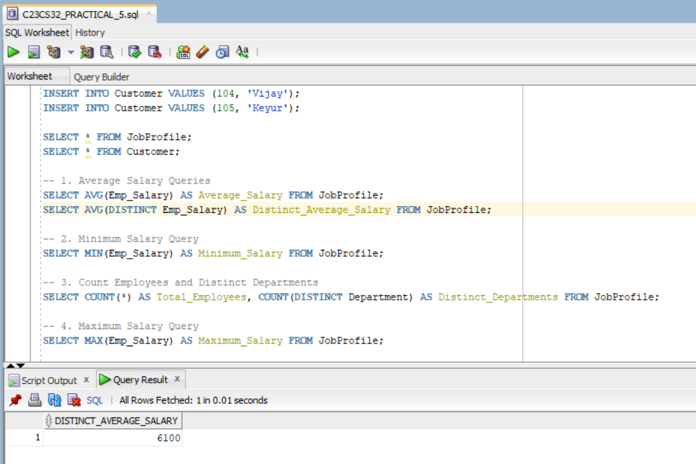

1. Retrieve the minimum salary from the JobProfile table.

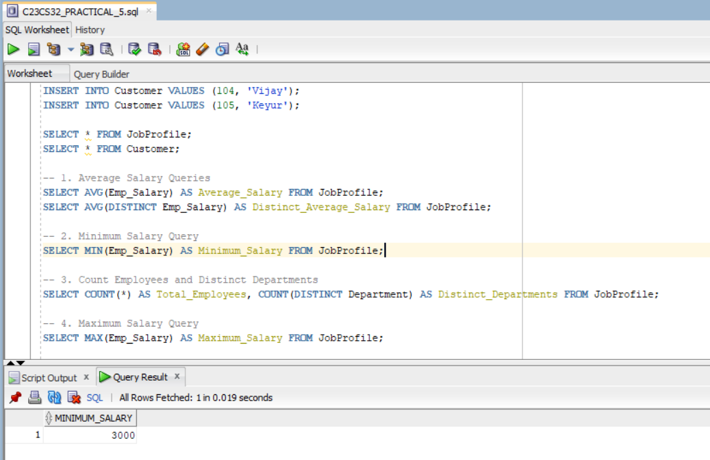

1. Count the total number of employees and distinct departments.

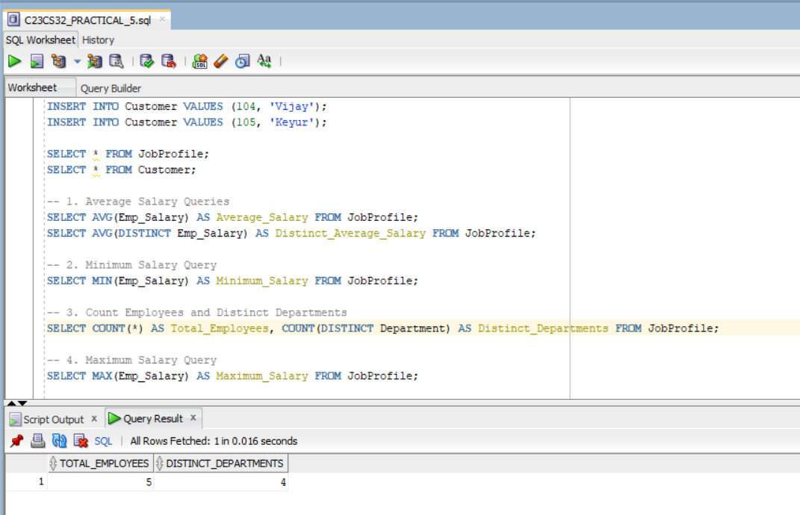

1. Retrieve the maximum salary from the JobProfile table.

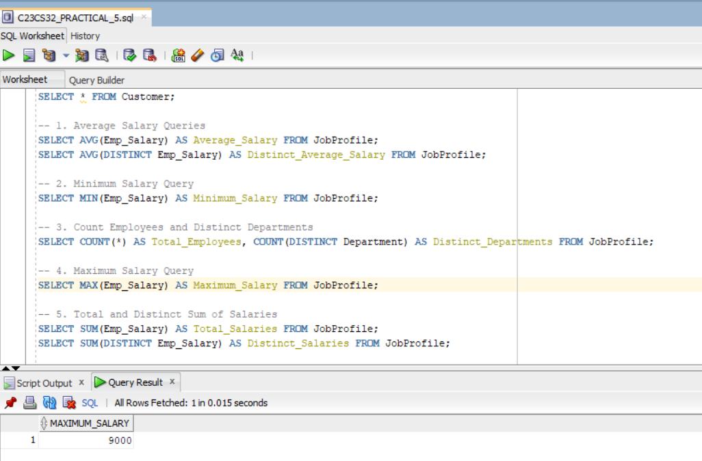

1. Calculate the total and distinct sum of all salaries.

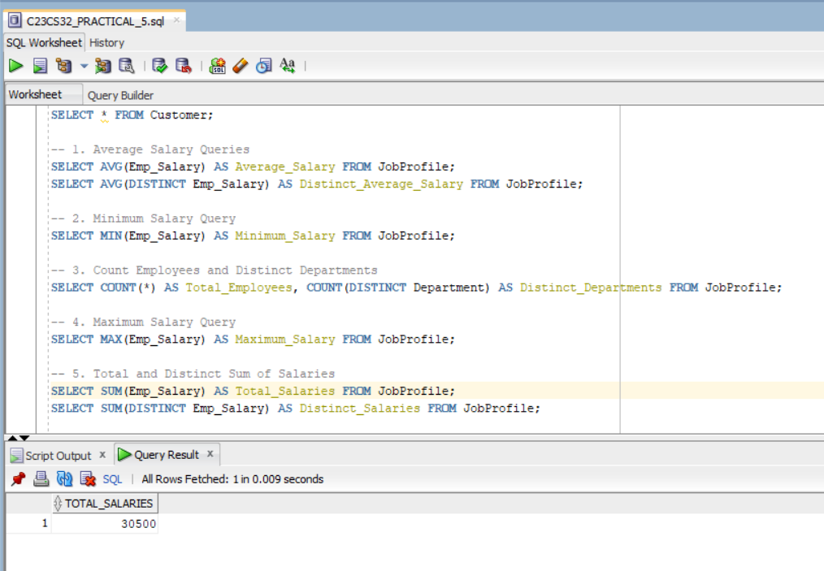

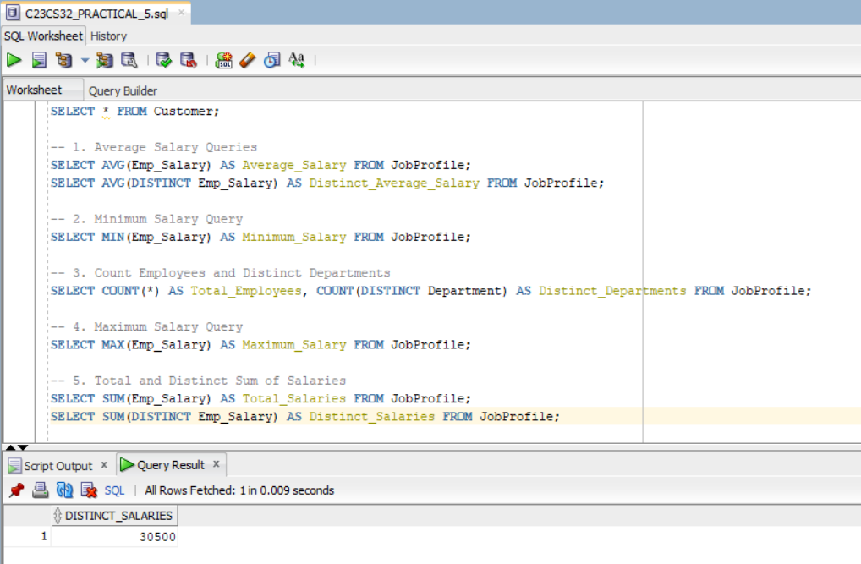

The finance team needs specific salary calculations for tax and benefits. Write SQL queries to:

1. Calculate the absolute difference between each employee’s salary and ₹1,000.

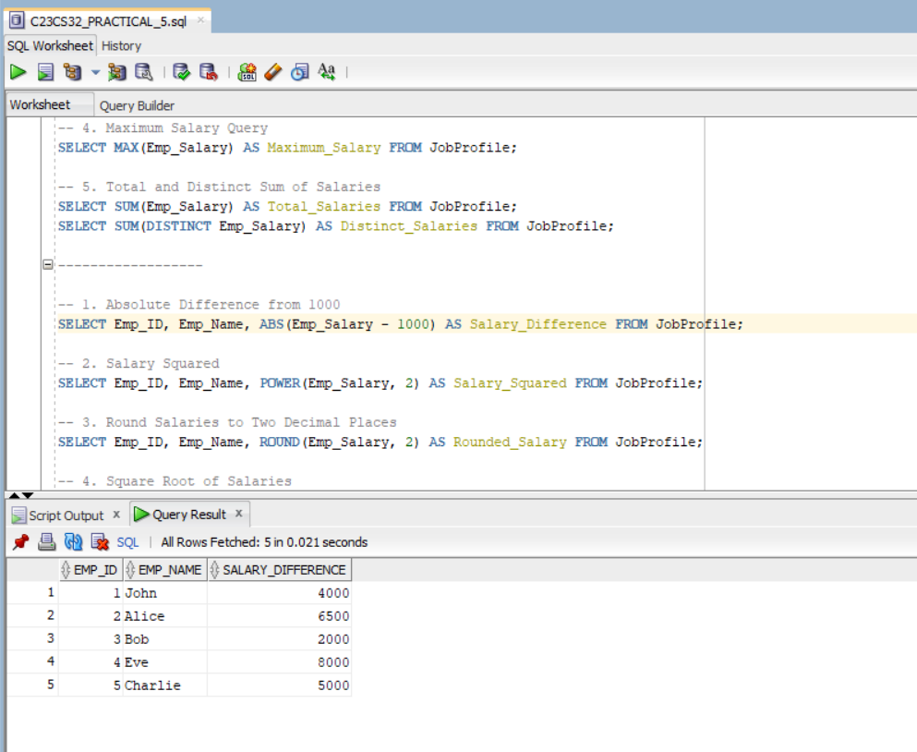

1. Compute the square of each employee’s salary.

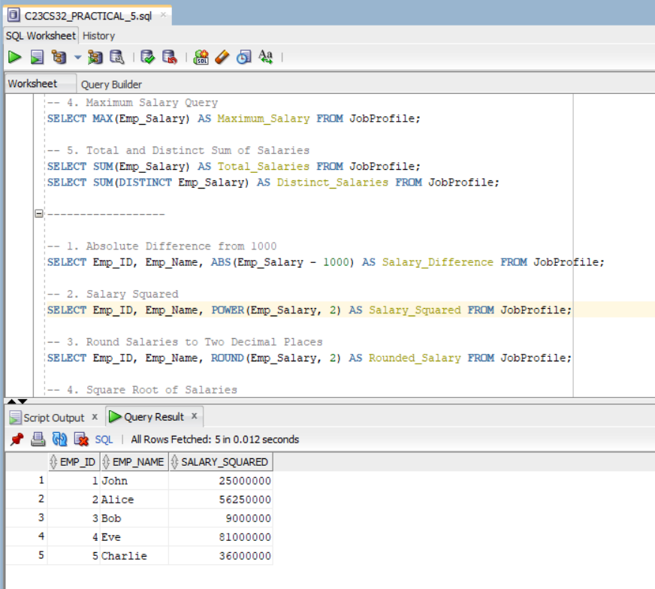

1. Round salaries to two decimal places.

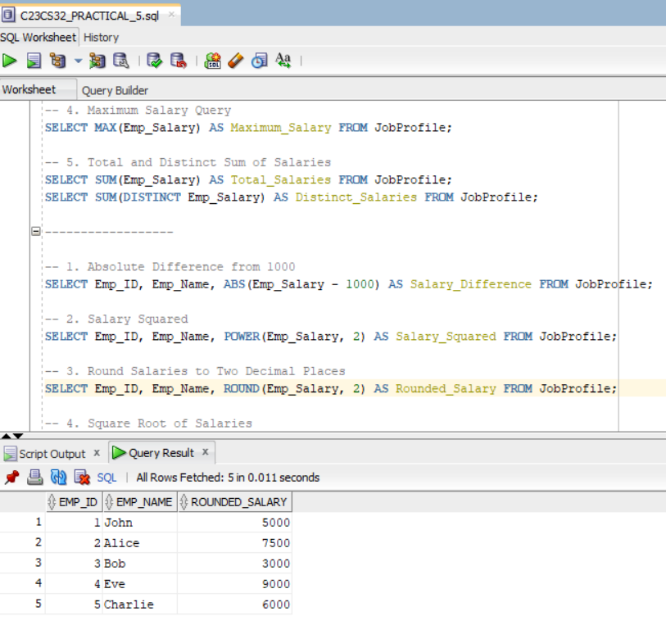

1. Find the square root of salaries.

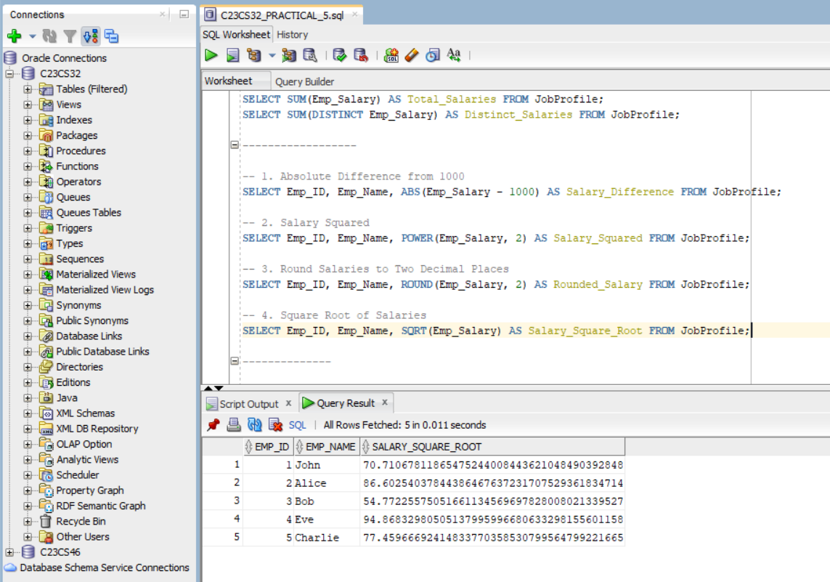

To ensure uniformity in names across systems, perform the following:

1. Convert all employee first names to lowercase, uppercase, and initial caps.

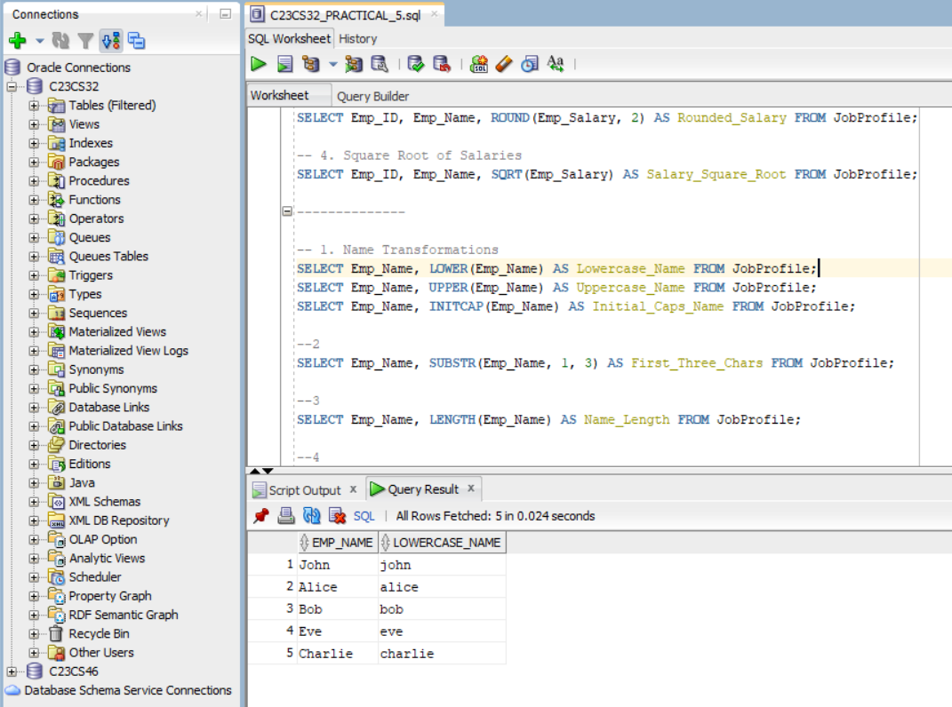

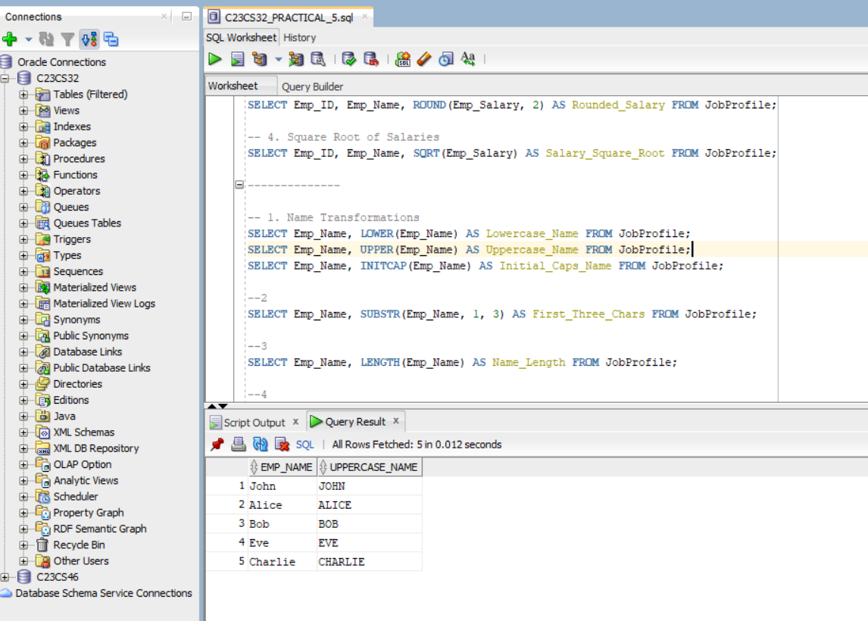

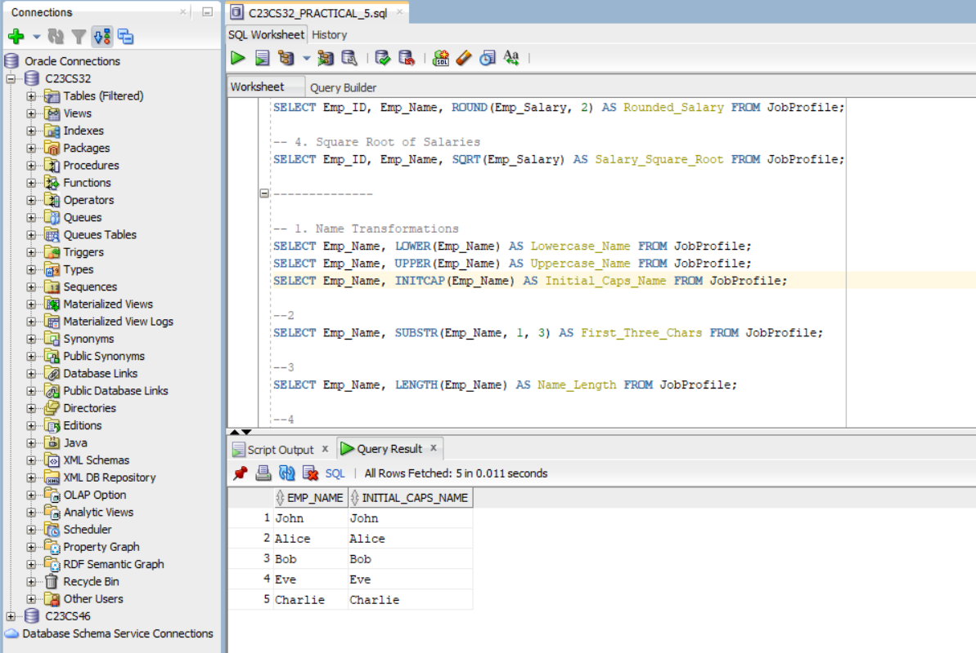

1. Extract the first three characters of employee first names.

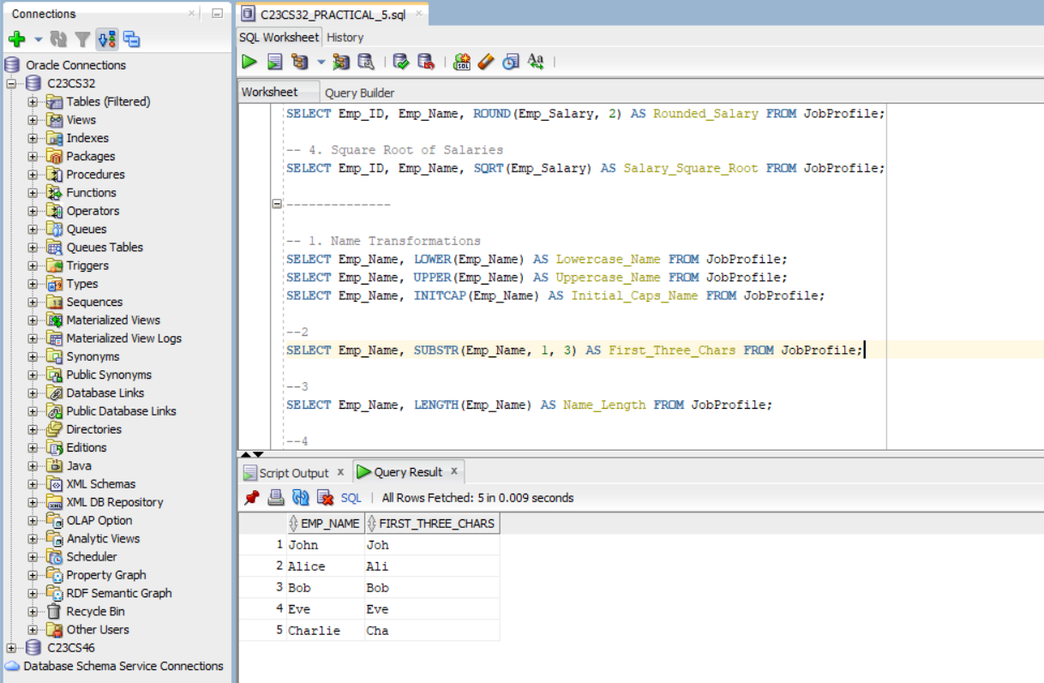

1. Find the length of each employee’s first name.

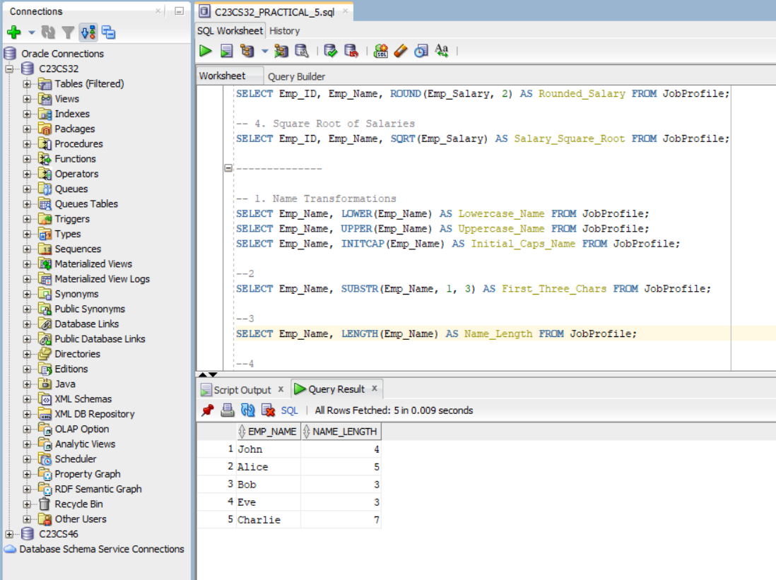

1. Remove leading 'A' and trailing 'a' from employee first names.

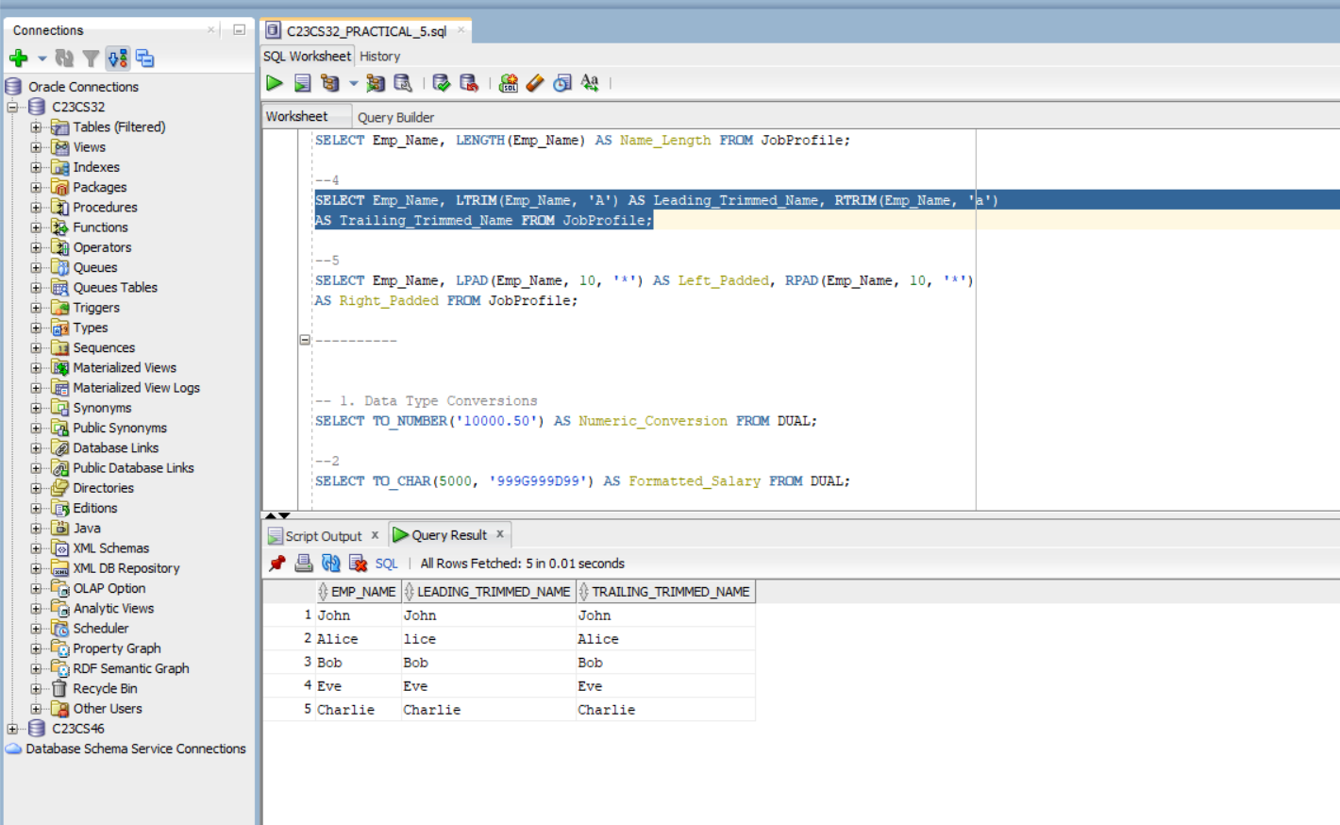

1. Pad employee first names with '*' on the left and right, ensuring a total length of 10.

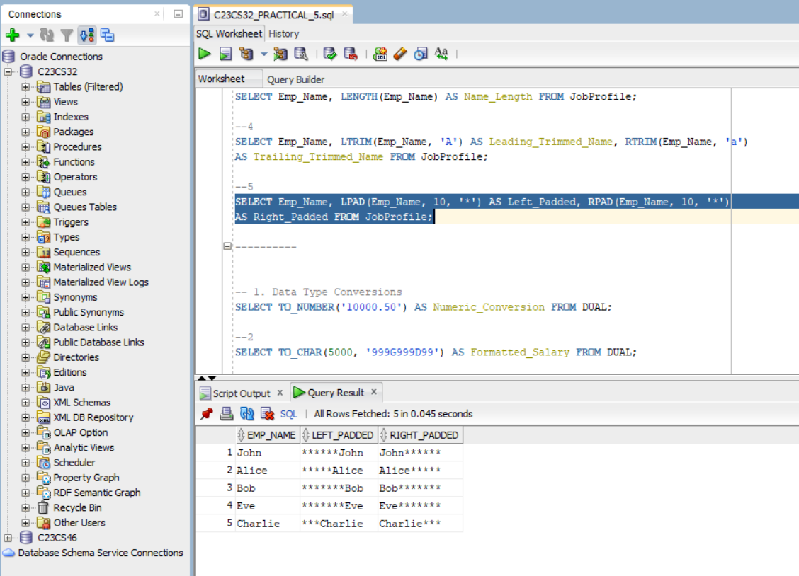

The data migration team requires conversions between different data types:

1. Convert a string representation of a salary to a numeric format.

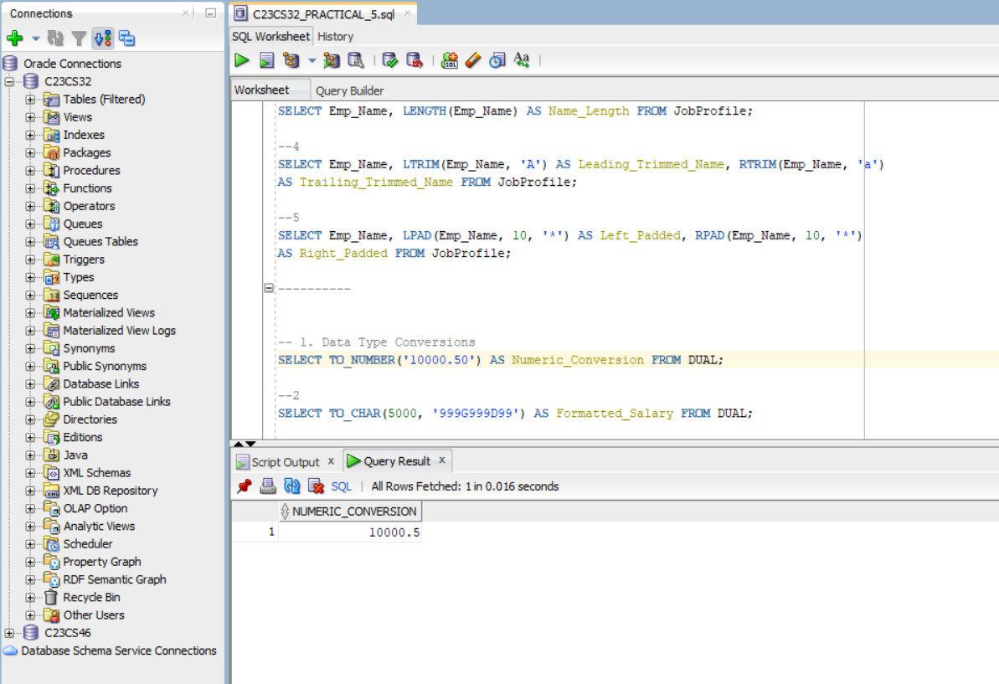

1. Format a numeric salary value into a string with specific formatting.

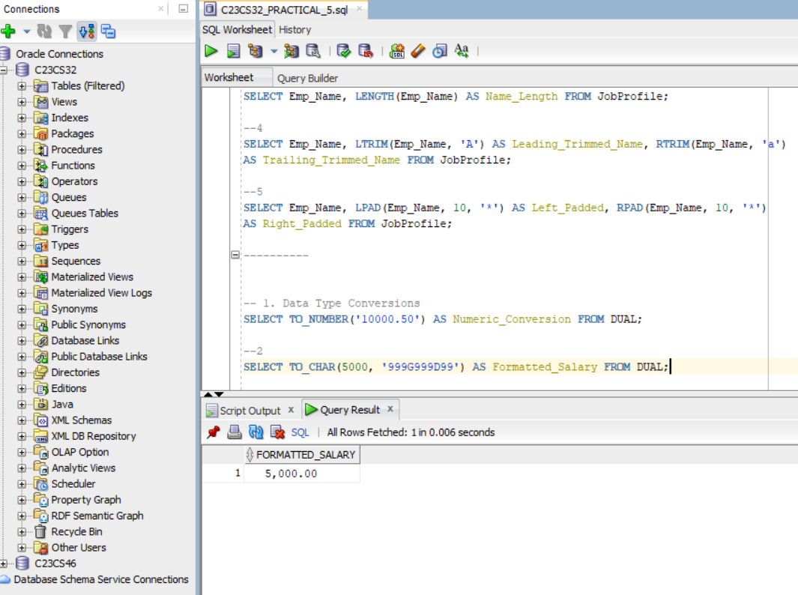

To assist in employee scheduling, perform the following:

1. Calculate the date after adding 6 months to the current date.

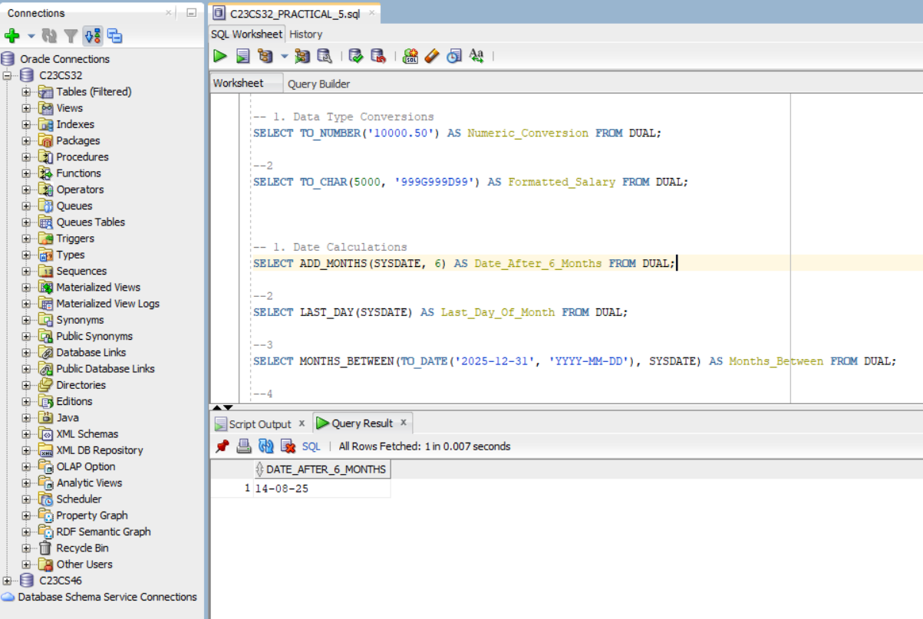

1. Retrieve the last day of the current month.

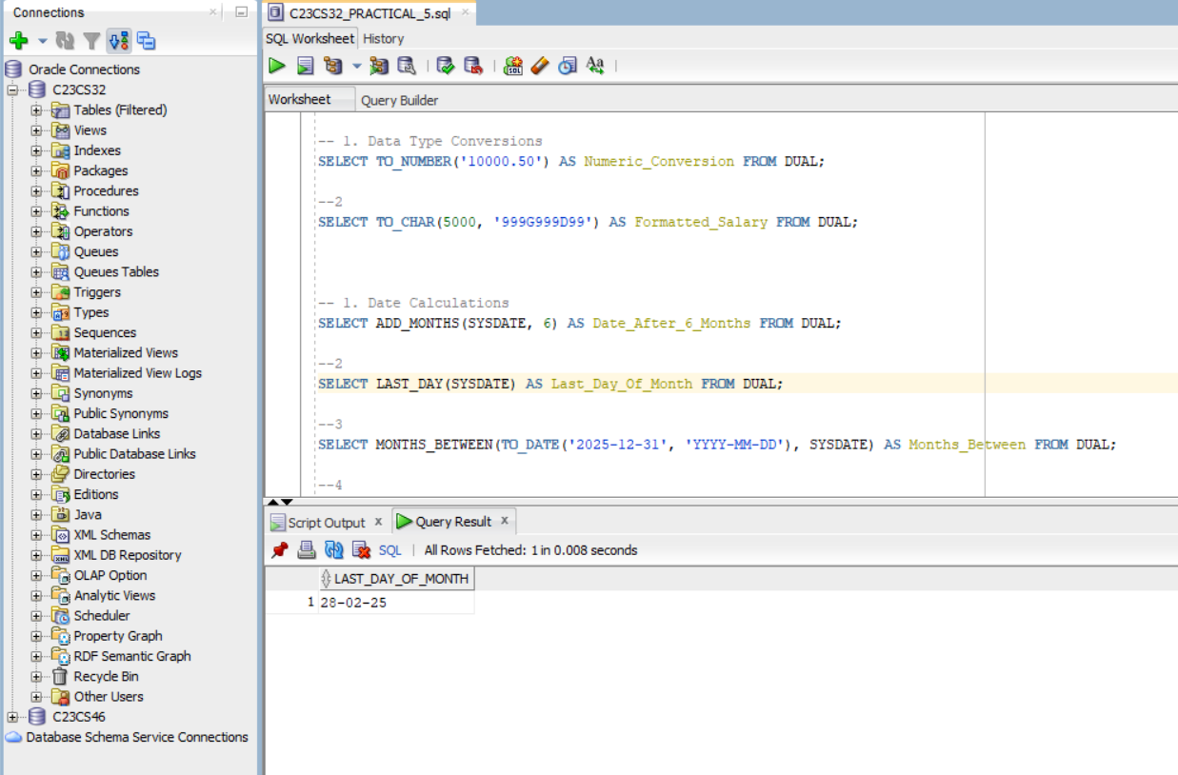

1. Calculate the number of months between two dates.

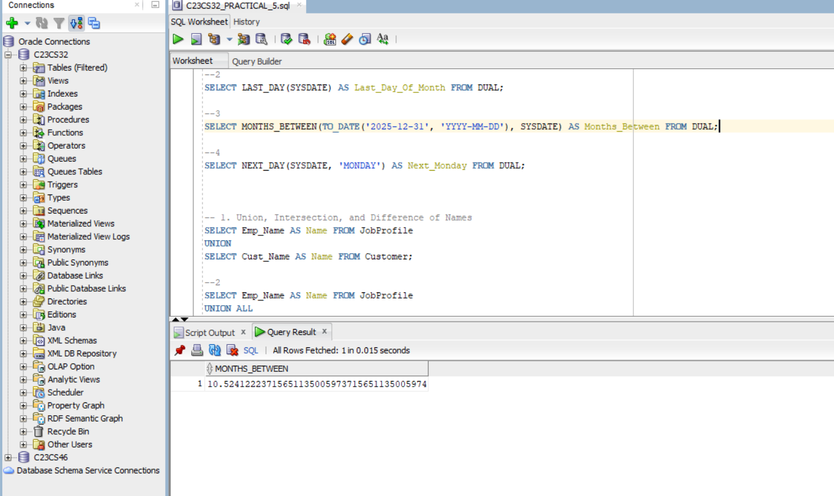

1. Find the next Monday from the current date.

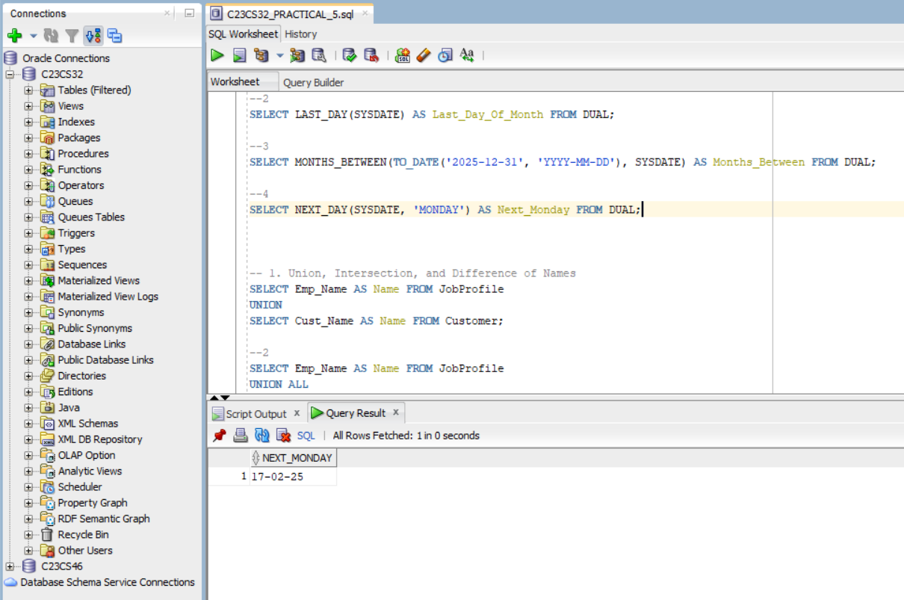

To identify overlaps and differences between employees and customers, write SQL queries to:

1. Retrieve the union of first names from employees and customers.

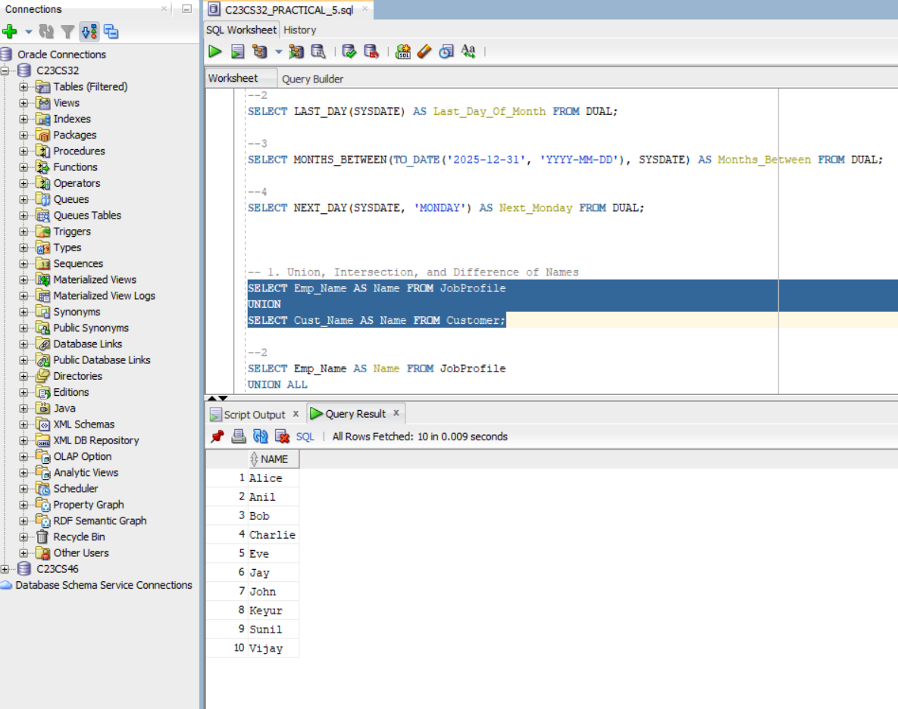

1. Retrieve the union of first names (including duplicates).

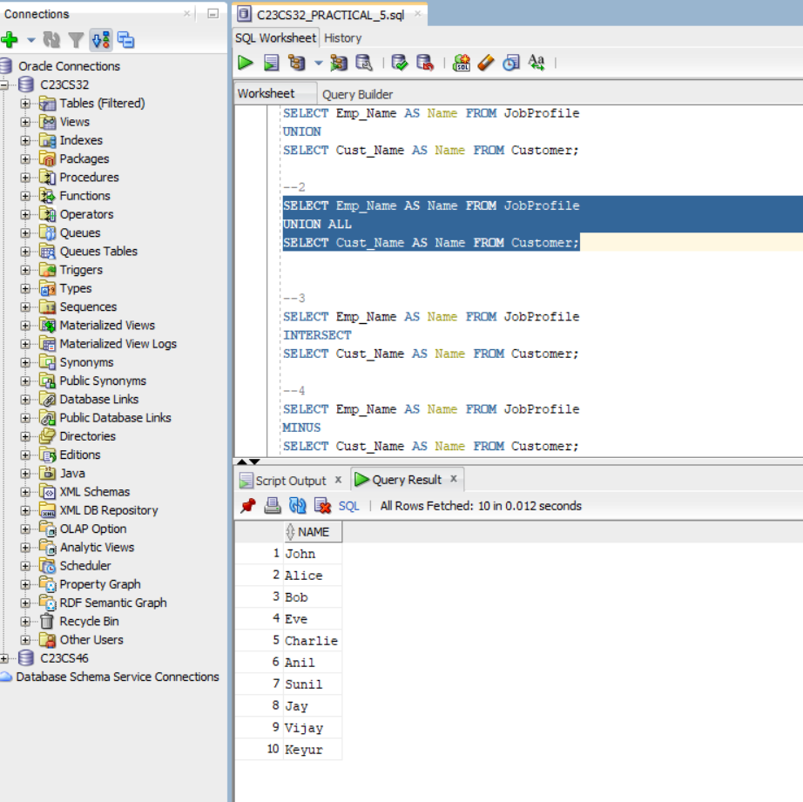

1. Find the intersection of first names from employees and customers.

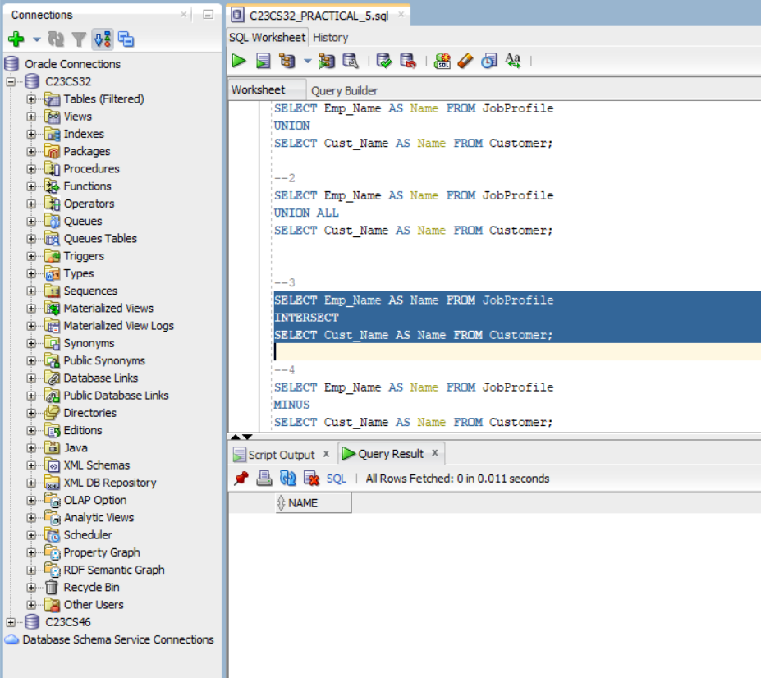

1. Identify first names present in the employees table but not in customers.

